“Heaven on Earth”

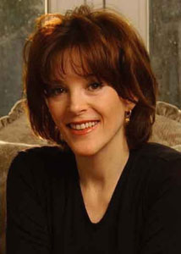

MARIANNE WILLIAMSON, World-renowned lecturer and best-selling author (Return to Love, Everyday Grace, Healing the Soul of America), and master teacher of A Course in Miracles, will speak at a benefit for ESTEEM, INC., to raise funds for homeless women and children, on Sunday, June 13 at 3 p.m. at Park Synagogue, 3300 Mayfield Rd., Cleveland Hts., Ohio. For tickets ($40 & $35) you can logon to www.esteem1.addr.com or call 216.382.1465 x2.

